Verification of Maximum Power Transfer Theorem

6.1 Purpose/Objective:
The aim of this experiment is-
- To be familiar with the Maximum Power Transfer theorem and also to verify it.
- To know about its applicability.

6.2 Theory:
- Maximum power transfer theorem may be stated as follows:
  - A resistive load will receive maximum power from a network when the load resistance is equal to the Thevenin resistance of the network applied to the load. That is, when
R_{L} = R_{Th}
  - But, if the load resistance is lower or higher in value than the Thevenin resistance of the network, its dissipated power will be less than the maximum.
- Let us consider the Thevenin’s equivalent circuit given below where R₂ is designated as the “load” resistor. We apply Maximum Power Transfer Theorem on this circuit:
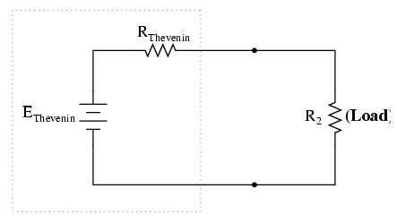
Figure-1: Thevenin equivalent Circuit

6.3 Equipment/ Apparatus:
- One regulated variable Power Supply (0-30 V)
- Ammeter and voltmeter
- Circuit Experiment Board (Breadboard)
- Fixed and variable resistors
- Connecting wires
- Cutting tools etc.

6.4 Cautions:
1. All connections should be tight and correct.
2. Switch off the supply when not in use.
3. Reading should be taken carefully.

6.5 Circuit Diagram:
The following Thevenin’s equivalent circuit is chosen to verify Maximum Power Transfer theorem.
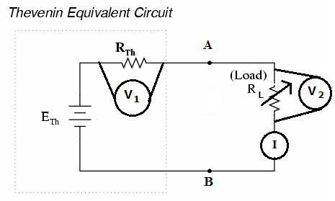
Figure-2: Thevenin’s equivalent of a circuit with variable load resistor

6.6 Procedure:
- Set up the circuit on the breadboard, as shown in figure-2.
- Now set the load resistor R_{L} to a minimum (i.e. 0 Ω). Find voltage V₁ and V₂ across R_{TH} and R_{L}. Take the ammeter reading I. Now calculate P_{TH}=V₁xI and P_{L}=V₂xI. Also calculate R_{L}=V₂/I.
- Repeat step 2 for different values of R_{L} (almost double of R_{TH}).
- Draw a graph of P_{L} versus R_{L}.

6.7 Data Table:
Note down the value of V_{TH} and R_{TH}. Fill up the following table and discuss on the experimental results.
Reading No. | V₁ (Volt) | V₂ (Volt) | I  (mA) | P_{L} (Watt | R_{L}  (Ohm) | P₁  (Watt) | P_{TH}=P₁+P_{L}  (Watt)
1.
2.
3.
4.
5.

6.8 Result:
Maximum Power Transfer Theorem has been verified.

6.9 Drawing P_{L} Vs R_{L} Graph:
- Using the data from the table above, we can plot a graph of load resistance, RL on the x-axis against power, PL on the y-axis for different values of load resistance.

- The PL-RL graph of maximum power transfer theorem should look like this:

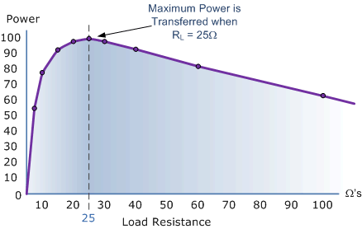

Figure-3: Graph of Power against Load Resistance

- From the above graph we can see that the Maximum Power Transfer occurs in the load when the load resistance, R_{L} is equal in value to the Thevenin’s equivalent resistance, R_{Th}, so then:

